# Main Solution:

In this challenge, you are given a zip file of the printer’s filesystem

Doing a google search would allow you to derive that the basic structure of a printer’s filesystem, it would usually contain a PJL, PostScript, saveDevice and webServer, similar to the zip file we were provided with

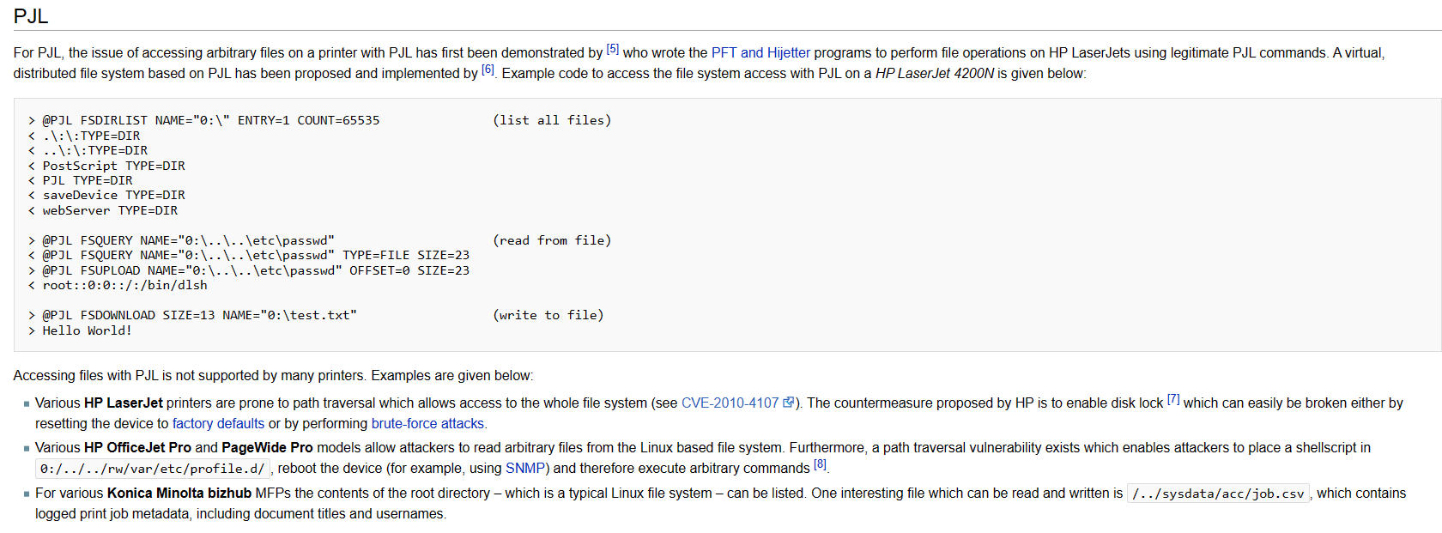

Source: <http://hacking-printers.net/wiki/index.php/File_system_access>

Furthering the research based on the metasploit auxiliary module “auxiliary/scanner/printer/printer_list_dir” we can see that under the saveDevice folder there should be a savedJobs which could be interesting?

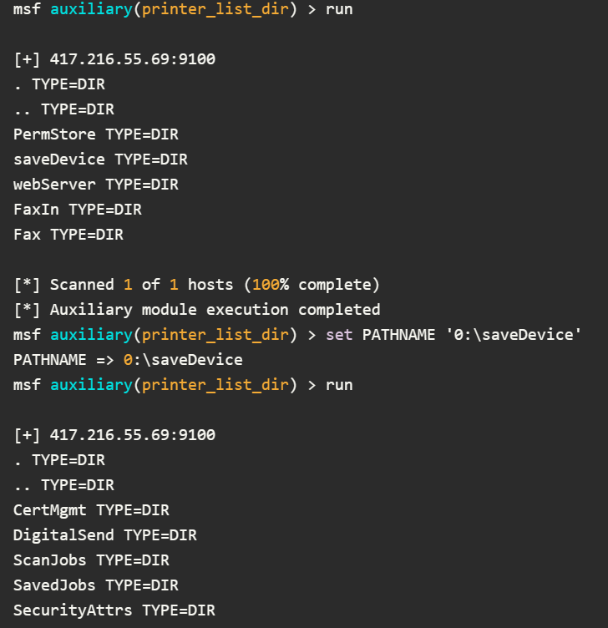

Source: <https://www.rapid7.com/blog/post/2014/01/24/hacking-printers-with-metasploit/>

Going into the zip file provided, we can see using a simple ls -lahR to recursively print through the available files/directories that there is a file “Factory.pdf”, keys and security that maybe interesting

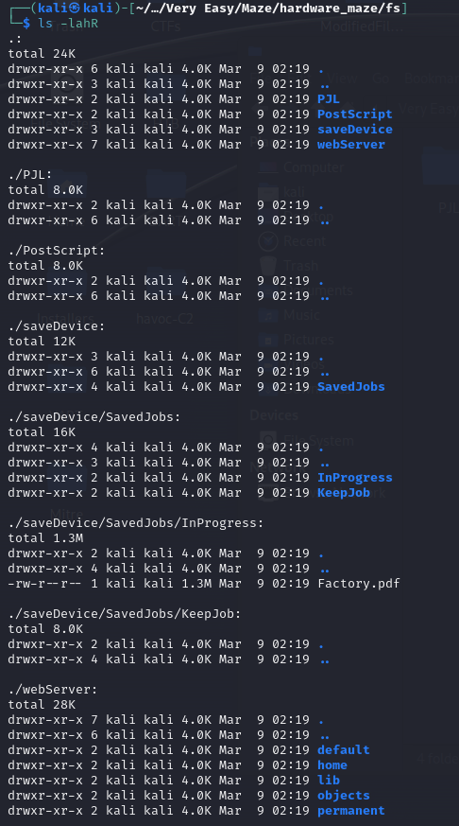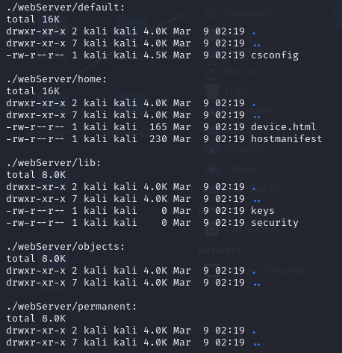

The keys and security files were empty while the Factory.pdf had the flag inside the file

